Contents

INTRODUCTION: 2

AIM: 2

THEORY: 2

MATERIAL AND EQUIPMENT REQUIRED: 6

OBSERVATION: 8

COMPARISION WITH THEORY: 16

CONCLUSON AND DISCUSSION: 16

*ADDITIONAL DISCUSSION:* 17

REFRENCES: 18

### INTRODUCTION:

Tensile and compressive tests using a Universal Testing Machine (UTM) assess a material’s strength and deformation. Tensile testing measures properties like ultimate strength, yield strength, and elongation by pulling the material apart. Compressive testing determines compressive strength and elasticity by applying a compressive load. These tests are essential for material selection and structural design.

### AIM:

To analyse the mechanical properties of various materials under tensile stress using a Universal Testing Machine (UTM) and record the changes that occur during testing.

### THEORY:

**Tension**

Tension refers to the pulling force exerted on a material, attempting to elongate it. It generates tensile stress and strain, which influence a material’s properties like yield strength and ultimate tensile strength. Tension is essential in engineering (structural, mechanical, aerospace, biomedical), where it affects the performance and durability of materials. Tensile testing using a Universal Testing Machine (UTM) measures these properties to determine material behaviour under stress. Failure under tension can occur through ductile failure (elongation), brittle failure (sudden rupture), or fatigue failure (cyclic loading).

**Stress**

Stress is the internal resistance of a material to deformation under an external force, measured as force per unit area (σ = F/A). It can be tensile, compressive, shear, bending, or torsional, depending on the applied force. Stress is related to strain through Hooke’s Law (σ = Ei), where E is Young’s Modulus. Stress analysis, including testing with tools like Universal Testing Machines (UTM) and Finite Element Analysis (FEA), is critical in engineering to ensure materials and structures can withstand loads. Excessive stress can lead to elastic or plastic deformation, fracture, or fatigue failure, which makes stress management essential in civil, mechanical, aerospace, and biomedical engineering.

**Strain**

Strain is the measure of deformation in a material due to an applied force, quantified as the change in length divided by the original length (ε = ΔL / L₀). It can be tensile, compressive, shear, or volumetric, and is dimensionless. Strain is related to stress through Hooke's Law (σ = Ei), where stress is proportional to strain in the elastic region, with E being Young's Modulus. Strain analysis is crucial in fields like structural, mechanical, aerospace, and biomedical engineering, ensuring materials perform safely and effectively under stress. Excessive strain can lead to elastic, plastic deformation, or failure through fracture or fatigue.

**Stress-Strain Curve**

The stress-strain curve represents the relationship between the applied stress and resulting strain in a material. It consists of key regions: the elastic region, where stress and strain are proportional, governed by Young's Modulus; the yield point, where permanent deformation begins; the plastic region, where deformation is irreversible; the ultimate tensile strength (UTS), the maximum stress before failure; and the fracture point, where the material breaks. The curve helps determine material properties like yield strength, toughness, and elongation, essential for material selection, structural design, quality control, and failure analysis in engineering.

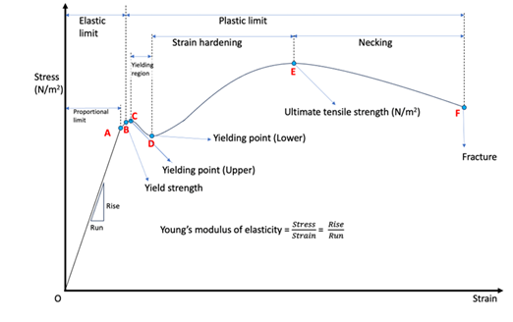

**Strength**

Strength is a material’s ability to withstand applied forces without failure. Key types include tensile strength, compressive strength, shear strength, flexural strength, fatigue strength, and impact strength. Strength is measured through tests such as tensile, compressive, shear, bending, and impact tests. Factors influencing strength include material composition, temperature, processing methods, and loading conditions. It is crucial in fields like construction, automotive, aerospace, and biomedical engineering, ensuring materials can safely withstand forces during use. Proper understanding and measurement of strength are vital for material selection, design, and safety.

**Hardness**

Hardness measures a material’s resistance to indentation, scratching, or wear. Common hardness tests include Brinell, Rockwell, Vickers, Knoop, and the Mohs scale. Hardness is influenced by factors like material composition, heat treatment, grain size, and work hardening. It plays a crucial role in material selection for wear-resistant components, quality control, and determining machinability. Harder materials are used in applications like cutting tools, bearings, and engine parts, ensuring durability and performance.

**Toughness**

Toughness is a material’s ability to absorb energy and undergo plastic deformation before fracturing, combining strength and ductility. It is measured through impact tests and the area under the stress-strain curve. Factors like material composition, temperature, grain structure, and heat treatment influence toughness. It is crucial in industries like construction, aerospace, automotive, and military, where materials must withstand impact or fluctuating loads. Materials with high toughness, such as mild steel, are vital for safety and durability in dynamic environments.

**Strain Hardening**

Strain hardening, or work hardening, occurs when a material becomes stronger and harder due to plastic deformation. As dislocations accumulate, they increase yield and tensile strength but reduce ductility. This effect is common in ductile metals like steel and aluminium, which gain strength through cold-working processes like rolling or drawing. While it improves strength, strain hardening can make materials more brittle, so heat treatments like annealing are used to restore ductility. It is widely applied in metalworking and manufacturing to enhance material strength in components.

**Proportional limit**

The proportional limit is the point on the stress-strain curve where a material stops following Hooke's Law and stress is no longer proportional to strain. Up to this point, the material deforms elastically and returns to its original shape after the load is removed. Beyond the proportional limit, plastic deformation begins. It is crucial in material design and quality control to ensure components remain elastic and do not deform permanently under normal loads.

**Yield Strength**

Yield strength is the stress at which a material starts to deform permanently, transitioning from elastic to plastic deformation. It is determined through tensile testing and depends on factors like material composition, heat treatment, grain size, and temperature. Yield strength is vital for material selection, design safety, and ensuring structural integrity in applications such as construction, automotive, and aerospace, helping prevent permanent deformation and failure under stress.

**Ultimate Tensile Strength**

Ultimate Tensile Strength (UTS) is the maximum stress a material can withstand before breaking under tension, determined through a tensile test. It is crucial for material selection and ensuring materials handle high tensile loads without failure. UTS is influenced by material composition, temperature, grain structure, and processing methods, and is essential in industries like construction, automotive, and aerospace for designing strong, safe, and durable components.

**Necking**

Necking is the localized reduction in cross-sectional area that occurs when a material reaches its ultimate tensile strength (UTS). It signals the start of plastic deformation in ductile materials and precedes fracture, concentrating strain in one area. If the material continues to elongate, failure occurs at the neck.

**Young Modulus and Poison ratio**

Young's Modulus (E) measures a material's stiffness, representing the ratio of tensile stress to tensile strain in the elastic region of its stress-strain curve. A higher value indicates a stiffer material, with units typically in Pascals (Pa) or GA. It is crucial for material selection and structural design to ensure minimal deformation under load.

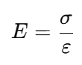

Poisson’s Ratio (ν) describes the ratio of lateral strain to axial strain when a material is stretched. It typically ranges from 0 to 0.5, with values around 0.2 to 0.3 for most materials. It is important for understanding how materials deform and is used in Finite Element Analysis (FEA) and material design.

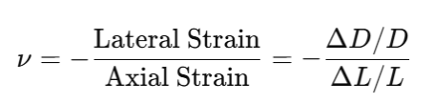

Both properties are essential for structural design, material selection, and ensuring materials perform effectively under different stresses.

**Compression**

Compression is a force that shortens or compacts a material, generating compressive stress and strain. It plays a crucial role in engineering, especially in structures like columns and beams that bear loads. Compressive testing, often done using a Universal Testing Machine (UTM), measures properties such as compressive strength and elastic modulus. Failure under compression can occur through buckling, crushing, or plastic deformation. Understanding compression is essential in civil, mechanical, aerospace, and biomedical engineering to ensure the stability and performance of materials under load.

**Fracture**

Fracture refers to the breaking of a material under stress, and can be classified into ductile, brittle, fatigue, and creep fracture based on the failure behaviour. Ductile fracture involves significant plastic deformation, while brittle fracture occurs with little deformation. Fatigue fracture results from cyclic loading, and creep fracture happens over time under constant stress, often at high temperatures. Fracture mechanics studies the behaviour of cracks in materials, with fracture toughness indicating a material's resistance to crack propagation. Factors like material properties, temperature, loading rate, and environment influence fracture behaviour. Understanding fracture is crucial in fields like aerospace, automotive, and construction for designing durable, safe components.

### MATERIAL AND EQUIPMENT REQUIRED:

**Universal Testing Machine**

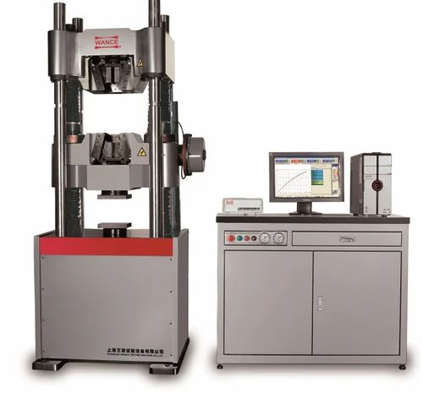

A Universal Testing Machine (UTM) is a sophisticated mechanical testing device used to evaluate the mechanical properties of materials under tension, compression, bending, and shear loads. It is an essential tool in materials science, engineering, and quality control, enabling precise measurement of a material's strength, elasticity, ductility, toughness, and failure characteristics. With advancements in automation, AI, and real-time data analysis, UTMs are becoming more powerful and efficient in evaluating materials for cutting-edge engineering applications.

**Components of a UTM (Universal Testing Machine)**

* **Load Frame** – Main structure with crossheads, guiding columns, and base.
* **Crosshead** – Moves to apply tensile or compressive loads.
* **Load Cell** – High-precision sensor for force measurement.
* **Actuator** – Hydraulic or electromechanical system for controlled load application.
* **Grips & Fixtures** – Secure the specimen; types include wedge, hydraulic, and pneumatic grips.
* **Extensometer** – Measures strain; advanced versions use digital or laser technology.
* **Control System** – Computerized unit for real-time data acquisition and analysis.

**Materials**

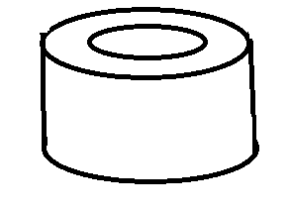**PVC pipe**

External diameter: 21 mm

Length: 24 mm

Thickness: 11 mm

Young’s Modulus: 2.5 - 4 GA

Poison’s Ratio: 0.35

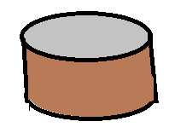**WPC**

Diameter: 9 mm

Thickness: 7.17 mm

Young’s Modulus: 0.001 - 0.03 GA

Poison’s Ratio: 0.4-0.5

**Magnesium sample**

Gauge Length: 20 mm

Width: 3.45 mm

Thickness: 2.98 mm

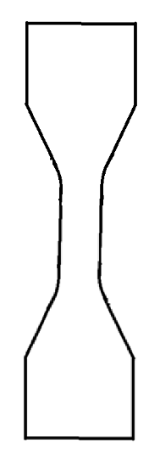Young’s Modulus: 45 - 50 GA

Poison’s Ratio: • 0.3 - 0.35

**Silicon Rubber sample**

Gauge Length: 30 mm

Width: 5.12 mm

Thickness: 4.80 mm

Young’s Modulus: 0.01 - 0.1 GA

Poison’s Ratio: 0.49

### OBSERVATION:

1. **PVC Pipe Sample Compression Test**

**Graph**

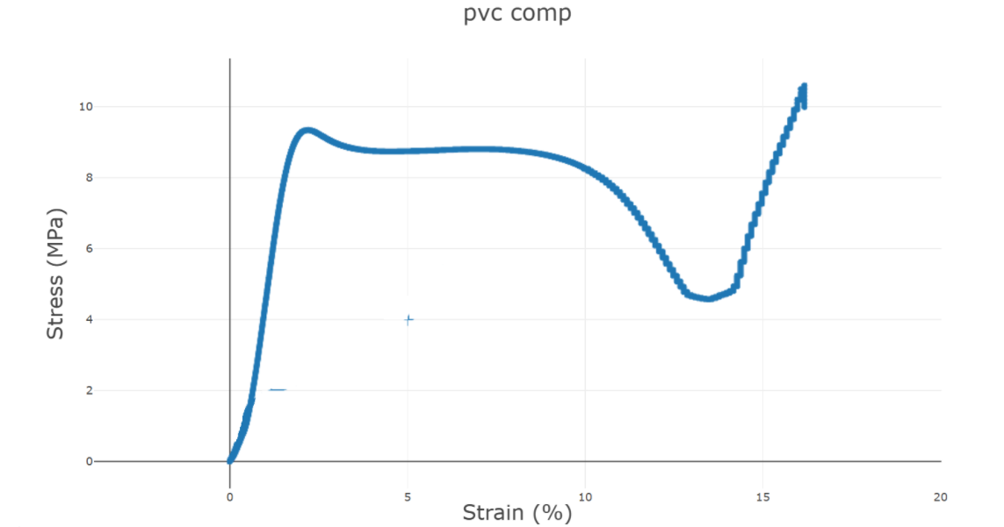

**Stress VS Strain**

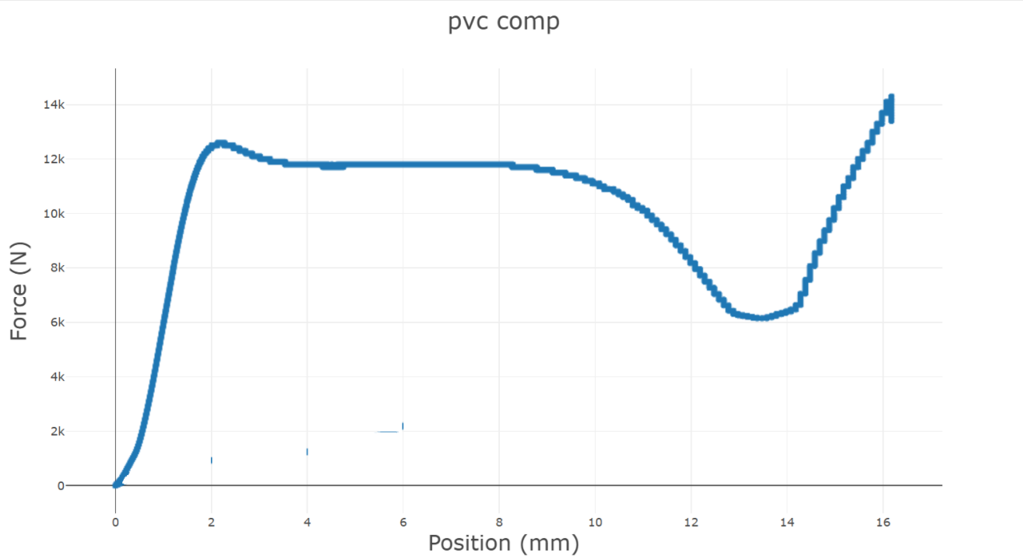

**Force VS Position**

**Calculation**

Ultimate Stress: 10.6 MPa

Maximum Force: 14300 N

Area: 1071.28 mm2

Calculated Ultimate Stress: 13.34 MPa

**Abaqus Analysis**

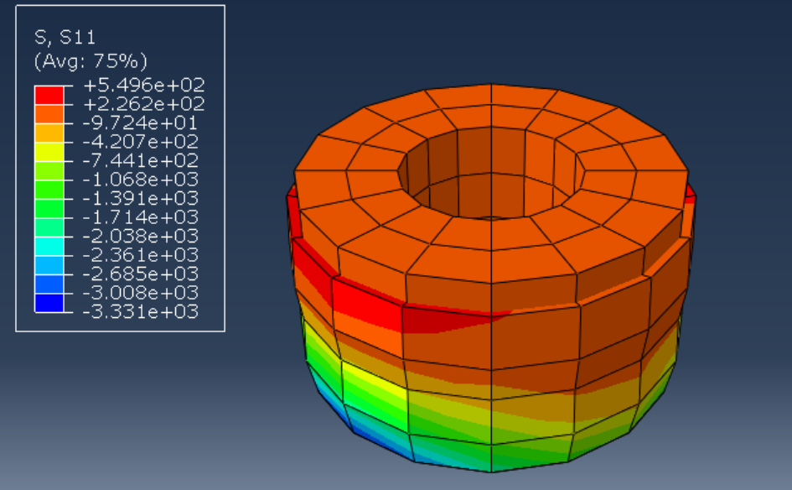

1. **WBC Sample Compression Test**

**Graph**

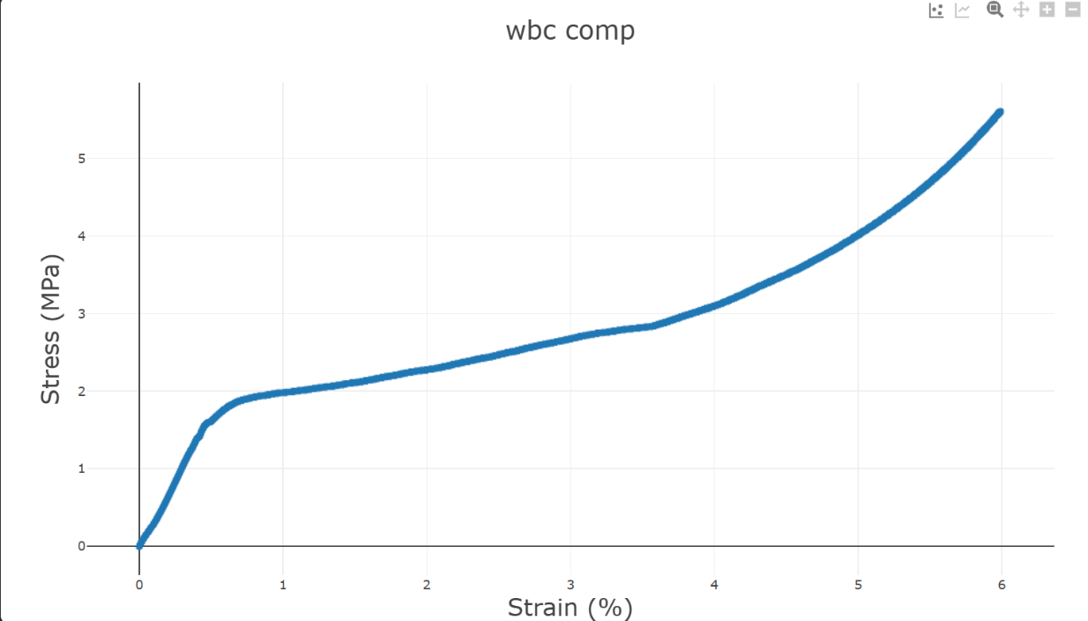

**Stress VS Strain**

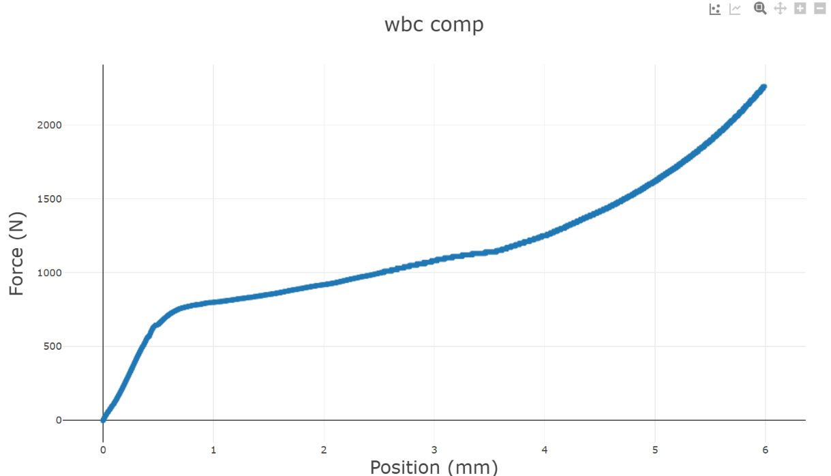

**Force VS Position**

**Calculation**

Ultimate Stress: 5.61 MPa

Maximum Force: 2260 N

Area: 412.22 mm2

Calculated Ultimate Stress: 5.47 MPa

**Abaqus Analysis**

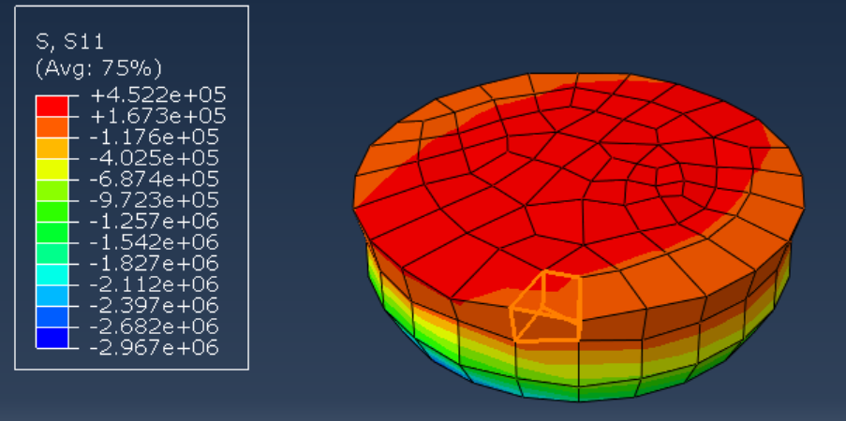

1. **Magnesium Sample Tensile Test**

**Graph**

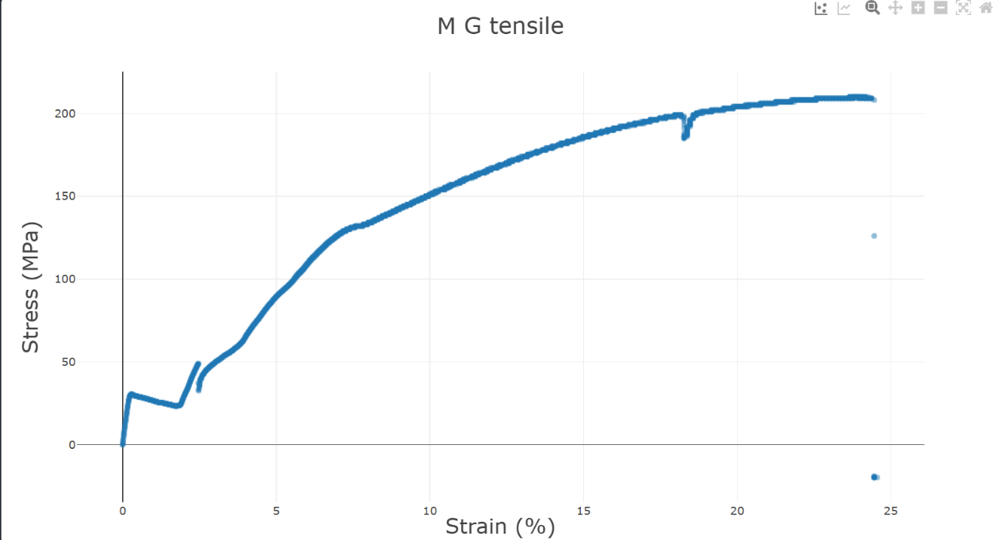

**Stress VS Strain**

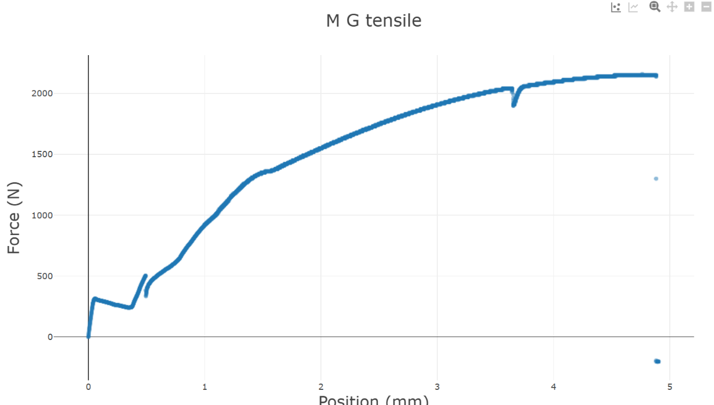

**Force VS Position**

**Calculation**

Ultimate Stress: 210 MPa

Maximum Force: 2160 N

Area:10.281 mm2

Calculated Ultimate Stress: 210.09 MPa

**Digital Image Corelation**

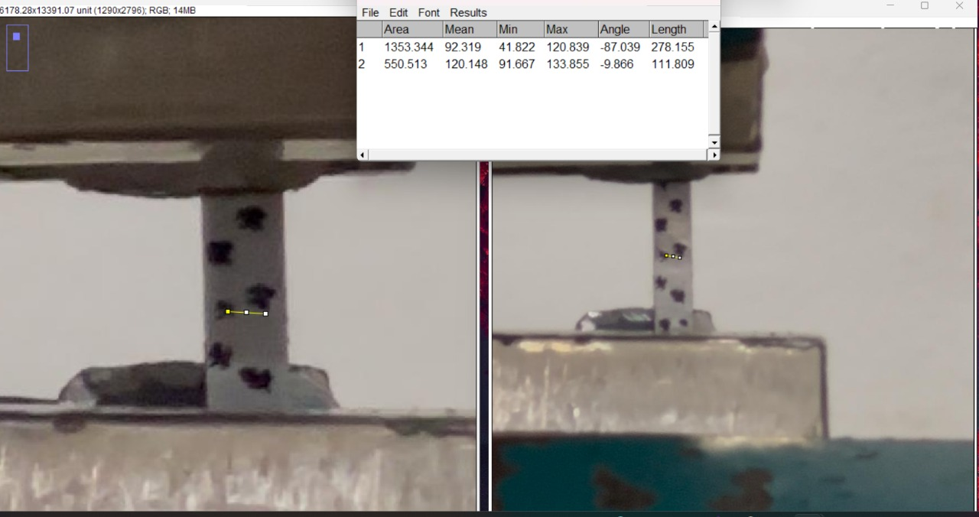

Poison Ratio: 0.401

**Abaqus Analysis**

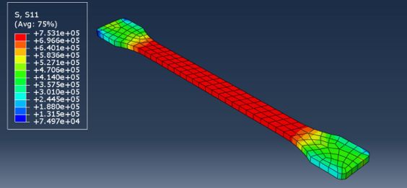

1. **Silicon Rubber Tensile Test**

**Graph**

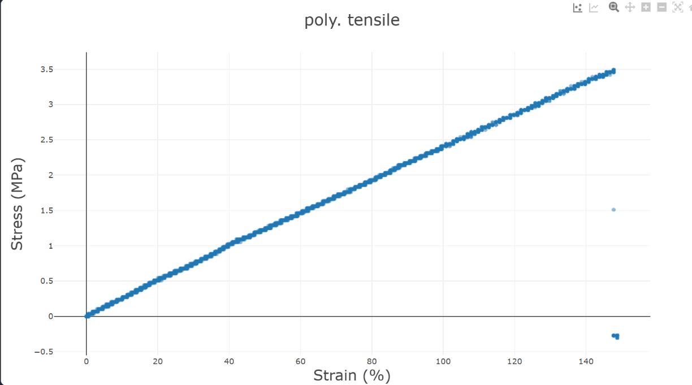

**Stress VS Strain**

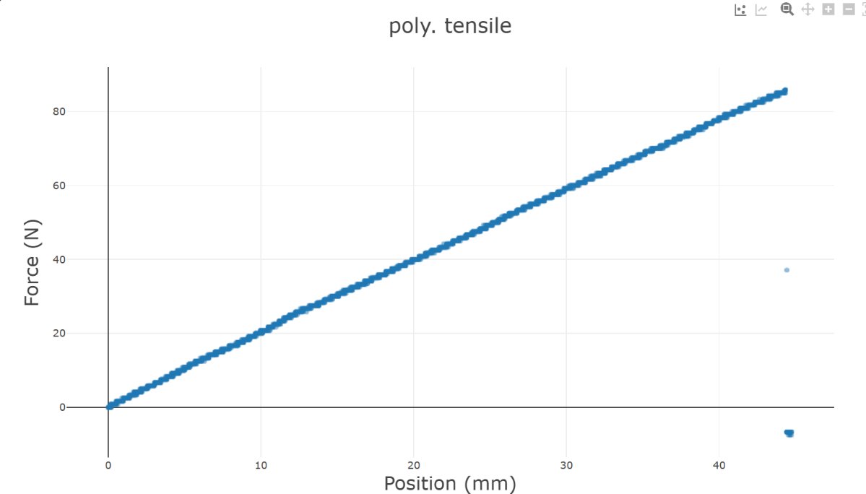

**Force VS Position**

**Calculation**

Ultimate Stress: 3.49 MPa

Maximum Force: 85.8 N

Area: 24.576 mm2

Calculated Ultimate Stress: 3.4912 MPa

**Digital Image Corelation**

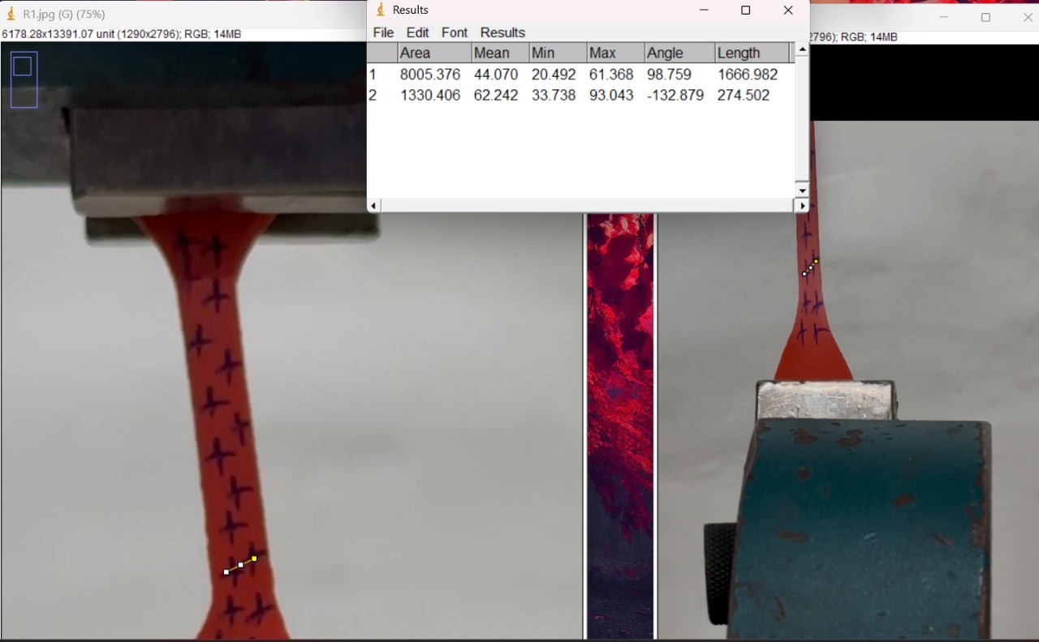

Poison Ratio: 0.164

**Abaqus Analysis**

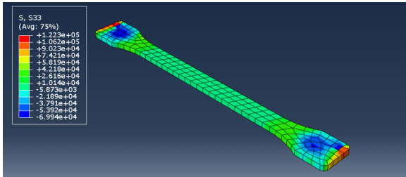

### COMPARISION WITH THEORY:

In all four experiments, samples were subjected to compression (WBC sample and PVC pipe) or tension (magnesium and silicon rubber samples) using a Universal Testing Machine (UTM). The stress-strain curves for both tests initially showed a linear region up to the proportional limit, where stress was proportional to strain (Hooke’s Law), and the material exhibited elastic behaviour. Beyond the elastic limit, plastic deformation began at the yield point, with two distinct stages:

* Upper yield point – Marks the end of elastic behaviour.
* Lower yield point – Indicates the onset of plastic deformation.

In the plastic region, deformation continued until reaching maximum stress, after which less stress was required for further deformation due to void formation and necking. For compression, the PVC pipe exhibited a sudden dip in the curve due to bulging, where the pipe expanded outward until its upper and lower surfaces touched, causing the curve to rise again. Compression was controlled up to half the initial height.

For tensile tests, the material deformed until reaching Ultimate Tensile Strength (UTS), the maximum stress it could withstand before necking. After this, localized reduction in cross-section led to fracture failure. Silicon rubber showed a gradual transition, indicating higher ductility, while magnesium exhibited higher yield strength and UTS, demonstrating greater stiffness and strength. Overall, the experimental results aligned with theoretical expectations, confirming material behaviour under tensile and compressive loads.

### CONCLUSON AND DISCUSSION:

**Discussion and Conclusion**

The Universal Testing Machine (UTM) plays a vital role in evaluating the mechanical properties of materials under tensile and compressive loads, such as yield strength, ultimate tensile strength (UTS), elastic modulus, and fracture point. The stress-strain curve generated from these tests is essential in material selection, structural design, and quality control, ensuring that materials meet safety and performance standards in industries like construction, aerospace, automotive, and manufacturing. It also aids in failure analysis and the design of lightweight, strong components in applications like biomedical implants and automotive parts.

During the experiment, magnesium presented challenges for tensile testing due to its low ductility, brittle nature, and hexagonal close-packed (HCP) crystal structure, leading to sudden fracture without significant necking. Its low fracture toughness and temperature sensitivity further complicated the testing. To improve testing, careful gripping, controlled loading rates, and elevated temperature conditions are required to reduce its brittleness.

In conclusion, the UTM tests confirmed theoretical expectations and provided valuable insights into material behaviour under stress. The results highlight the importance of understanding material properties for designing safe, durable, and efficient components in real-world applications.

### ADDITIONAL DISCUSSION:

**Dog Bone Structure**

A dog bone structure is a shape used in tensile testing, designed with a narrow central section to ensure failure occurs at this point under stress, not at the grips. The wider ends and reduced middle resemble a dog bone. This shape helps accurately measure material properties like yield strength, ultimate tensile strength, and elongation. It is commonly used for metal and plastic testing to ensure consistent results.

**ASTM Standards**

ASTM Standards are global guidelines that standardize testing, materials, and procedures across industries like engineering, construction, and manufacturing. They ensure consistent quality, safety, and performance, providing methods for testing, inspection, and measurement. Widely recognized by regulatory bodies and manufacturers, these standards ensure reliability and compatibility in products and materials.

**Bulging, Buckling and Bending**

Buckling, bending, and bulging are structural deformations caused by different loads. Buckling occurs when compressive stress exceeds a critical limit in slender structures, causing lateral deformation. Bending happens when an external load causes a material to curve, with tension on one side and compression on the other. Bulging is when a material swells outward, usually due to internal pressure or compressive forces, often seen in thin-walled structures like pipes. Each phenomenon requires careful design consideration to maintain structural integrity.

**Grain Boundary**

Grain boundaries are the interfaces between crystal grains in a material and influence its strength and ductility. They can strengthen the material by hindering dislocation movement (Hall-Petch effect) but may also serve as sites for fracture initiation, especially in brittle materials.

**Digital Image Corelation**

**Digital Image Correlation (DIC)** is a non-contact optical method used to measure **deformation** and **strain** on materials by tracking a speckle pattern under load. It provides high-precision data on surface deformations and is especially useful for **complex, non-uniform deformations** in **2D or 3D**.

**Why different Ultimate stress theoretically and experimentally?**

The calculated stress can differ from the observed stress in a UTM experiment due to factors like measurement errors (force and area inaccuracies), specimen imperfections (surface defects or non-uniformity), non-uniform strain distribution (e.g., necking), and grip effects (stress concentrations at grips). Environmental factors like temperature and humidity can also affect material properties. Additionally, theoretical calculations assume ideal conditions that may not reflect real-world material behaviour, especially when the material enters plastic deformation.

### REFRENCES:

* <https://www.geeksforgeeks.org/stress-strain-curve/>
* <https://theconstructor.org/practical-guide/universal-testing-machine-components-functions/2449/>
* <https://en.wikipedia.org/wiki/Digital_image_correlation_and_tracking>
* <https://byjus.com/physics/poissons-ratio/>
* <https://www.fitcoindia.com/product-category/testometric/?msclkid=fe596debc26311ed7ef30a422bd65006&utm_source=bing&utm_medium=cpc&utm_campaign=Testometric&utm_term=universal%20testing&utm_content=Tensile%20Tester>